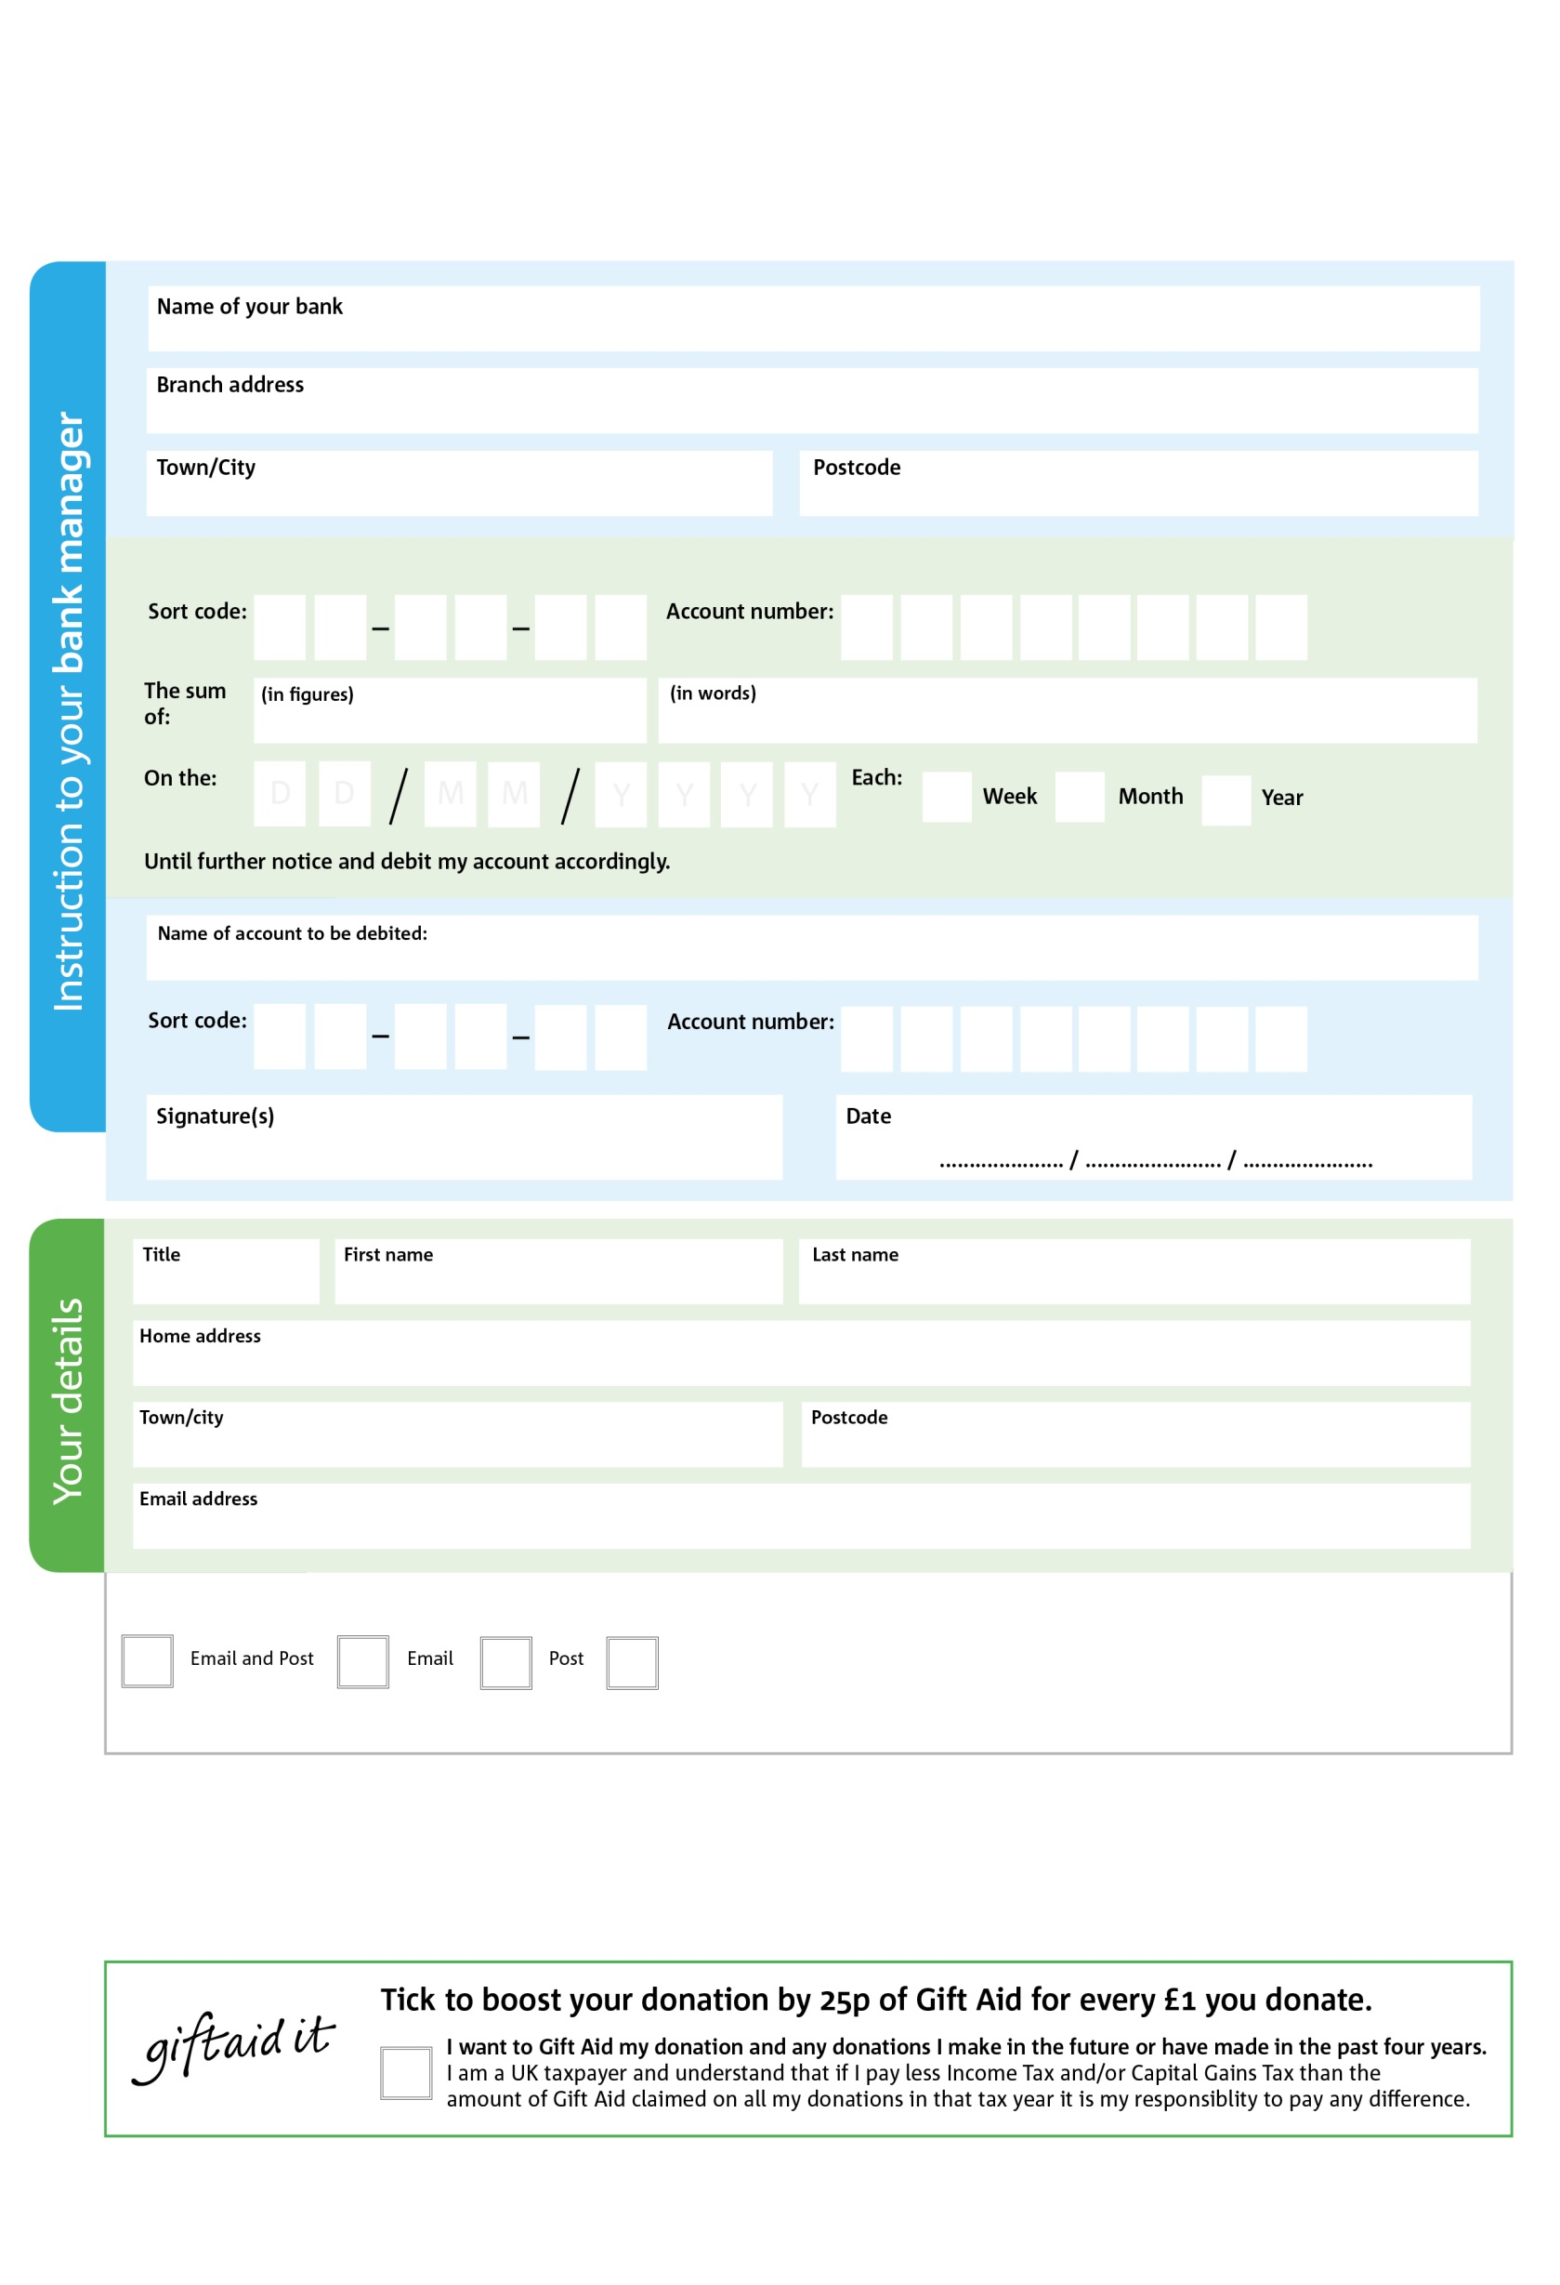

**Data protection**

*Long Eaton & Sawley Foodbank is committed to protecting your privacy and will process your personal data in accordance with current Data Protection legislation. Long Eaton & Sawley Foodbank collects information to keep in touch with you and supply you with information relating to our work. To unsubscribe from our newsletter, send a message to the email address above with the word unsubscribe in the subject line. A full data privacy statement for financial donors is available from the foodbank on request.*

**Please pass this form onto the foodbank, using the foodbank’s address at the bottom, who will save a copy for their records.   
They will then send it onto your named bank or building society.**

**Standing Order Mandate**

**www.longeatonsawley.foodbank.org.uk**

Please pay Long Eaton & Sawley Foodbank,

Reg. Charity No: 1152886 | Reg. in England & Wales WaWales

POSTAL ADDRESS: Long Eaton & Sawley Foodbank, 165 Wilmot Street, Sawley, Long Eaton, NG10 3EL

8

V

7

V

0

V

6

V

7

V

2

V

3

V

5

V

3

2

3

1

0

6

We would love to keep you up to date with information about Long Eaton & Sawley Foodbank. Please tick your preference:

You can change your preferences any time by contacting us on 07950 547671 or emailing us at info@longeatonsawley.foodbank.org.uk

I do not wish to receive future communications from Long Eaton & Sawley Foodbank

You can change your preferences any time by contacting us on XXXXXXXXXXX or emailing us at XXXX@XXXXXXXXXX.foodbank.org.uk

I do not wish to receive future communications from XXXXXX Foodbank